**RamraoAdik Institute of Technology**

**(Department of Compute 99od r Engineering)**



**Mini Project Report**

**On**

**Image Restorer Using OpenCV**

**Subject-: Open Source Technology Lab**

***Presented By***

|  |  |  |
| --- | --- | --- |
| Roll No | Batch-Sr. No | Name |
| ***16CE7033***  ***16CE7022***  ***16CE7018*** | ***C3-15***  ***C3-4***  ***C3-6*** | ***Prasanna Rajendra***  ***Navjot Singh Rajput***  ***Satweek Rajput*** |
|  |  |  |

***Under the guidance of***

**Ms. Snehal Mumbaikar**

**Signature of Internal Examiner Signature of External Examiner**

**Abstract**

In this report, we present the detailed development and implementation of photo restoration using OpenCV. The Image Restorer uses CV2 functions for reading image and  generate a restored image. Here different cv2 function are used to detect destroyed area by thresholding image at a high thresholding value on which restoration has to be performed.Inpaint function helps to paste neighbouring colour so as to get a clear image without any distortion hera mask image plays an important role for detection for the destroyed area.

**Table of Contents**

|  |  |  |
| --- | --- | --- |
| **Sr. No.** | **Contents** | **Page No.** |
| 1. | Introduction | 4 |
| 2. | Implementation | 5 |
| 3. | Result | 6 |
| 4. | Conclusion | **8** |

**Chapter 1**

**INTRODUCTION**

Most of you will have some old photos at your home with some black spots, some strokes etc on it. Have you ever thought of restoring it back? We can’t simply erase them in a paint tool because it is will simply replace black structures with white structures which is of no use. In these cases, a technique called image inpainting is used. The basic idea is simple: Replace those bad marks with its neighboring pixels so that it looks like the neighborhood

***OPENCV***

OpenCV (Open Source Computer Vision Library) is released under a BSD license and hence it’s free for both academic and commercial use. It has C++, Python and Java interfaces and supports Windows, Linux, Mac OS, iOS and Android. OpenCV was designed for computational efficiency and with a strong focus on real-time applications. Written in optimized C/C++, the library can take advantage of multi-core processing.

OpenCV-Python is Python wrapper for original OpenCV C++ implementation. OpenCV-Python makes use of NumPy, which is a highly optimized library for numerical operations with a MATLAB-style syntax. All the OpenCV array structures are converted to and from NumPy arrays.

Image Restorer uses different opencv function to read anad write image .

The application uses the functions which are:

Thresholding

Dillating

Inpaint

**Chapter 2**

**IMPLEMENTATION**

**2.1 Technologies Used**

To build our project the technologies used are as follows:

* Python 3.5
* OpenCV-Python

Image Restore uses two image first the real image and second mask image.. The mask image undergoes number of process in order to  detect the destroyed image. Then with the help of inpaint function Replace those bad marks with its neighboring pixels so that it looks like the neighborhood.

The mask image undergoes the process which are.

1.Marking: the mask image is converted into grayscale image so that the image data is reduced

2.Thresholding : Here thresholding is applied on grayscale image  here we threshold image at higher value.so as detect the destroyed area

3.Dilating: after thresholding we dilate the detected area so as we perform inpaint on the detected area.

4.inpainting :now we apply inpaint  to the detected area where it does Replace those bad marks with its neighboring pixels so that it looks like the neighborhood. With less radius value of inpaint function it works perfectly in replacing the pixels lesser the radius better the image.

**2.2 Code of Project**

import cv2

import numpy as np

img = cv2.imread('img.jpg')

cv2.imshow("real image",img)

cv2.waitKey(0)

#load imge

markdam = cv2.imread('mask.jpg',0)

cv2.imshow('marked',markdam)

cv2.waitKey(0)

ret, thresh1 = cv2.threshold(markdam,254,255,cv2.THRESH_BINARY)

cv2.imshow('thresold',thresh1)

cv2.waitKey(0)

kernel  = np.ones((7,7),np.uint8)

mask = cv2.dilate(thresh1,kernel , iterations=1)

cv2.imshow('dillate',mask)

cv2.imwrite('broken2.png',mask)

cv2.waitKey(0)

restored = cv2.inpaint(img,mask,3,cv2.INPAINT_TELEA)

cv2.imshow('restored',restored)

cv2.waitKey(0)

cv2.destroyAllWindows()

**Chapter 3**

**RESULT**

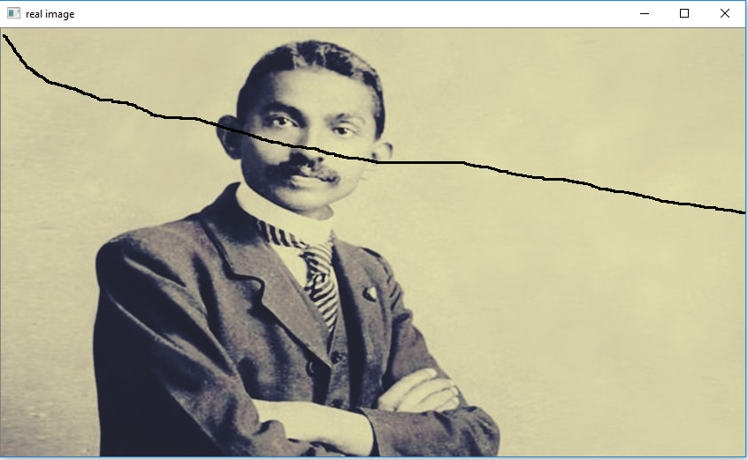

Real Image

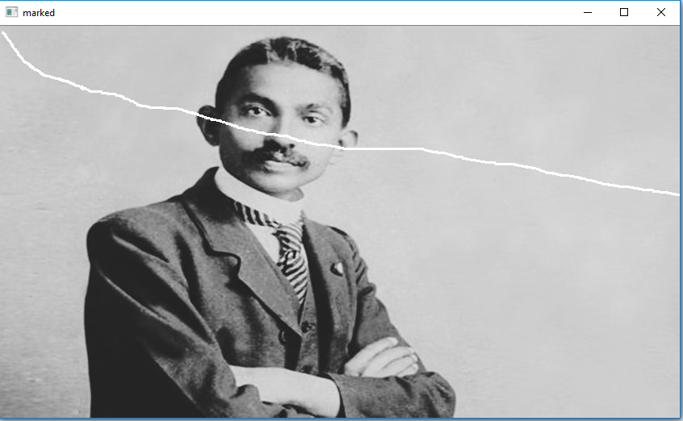

Marked Image

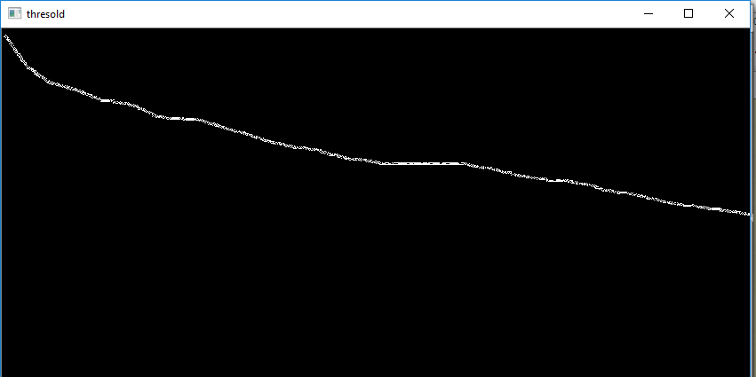

Threshold Image

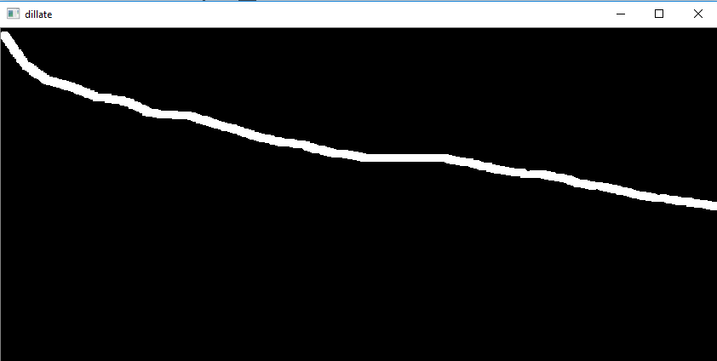

Dilating the detected area by thresholding

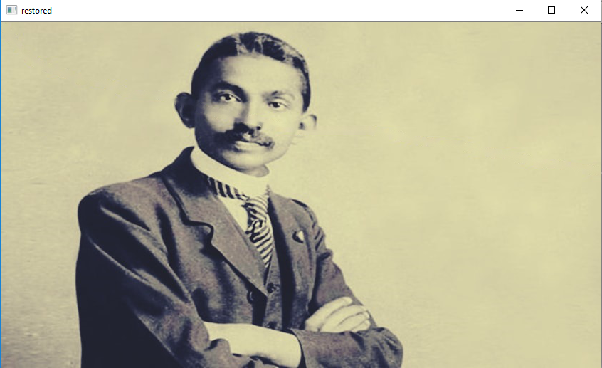

Restored image after using Inpaint

**Chapter 4**

**CONCLUSION**

The Image restorer application at a high level & this project basically allows users to restore the destroyed image with the help of Open CV . The Image Restorer uses CV2 functions for reading image and  generate a restored image. Here different cv2 function are used to detect destroyed area by thresholding image at a high thresholding value on which restoration has to be performed.Inpaint function helps to paste neighbouring colour to get a clear image